

Module Title

Internet Technology

Year

2026

Student Name: Rista Neupane

UWE:26033167

Week 4

Create a mockup design like your college website’s contact us page. Use your own creativity for this design.

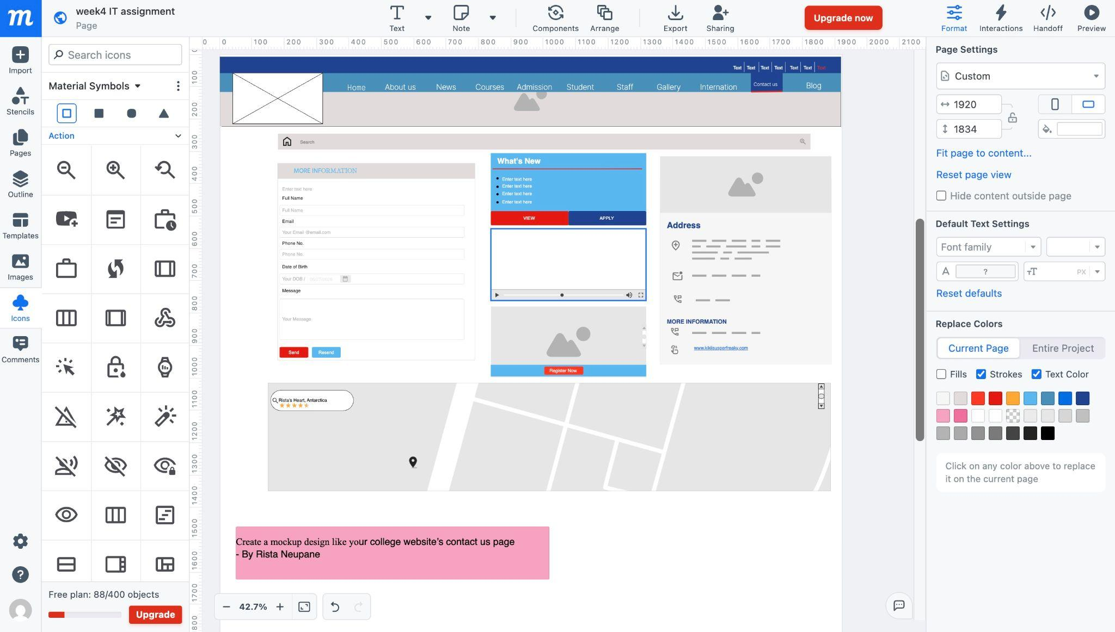
Process of making the mockup for the websit

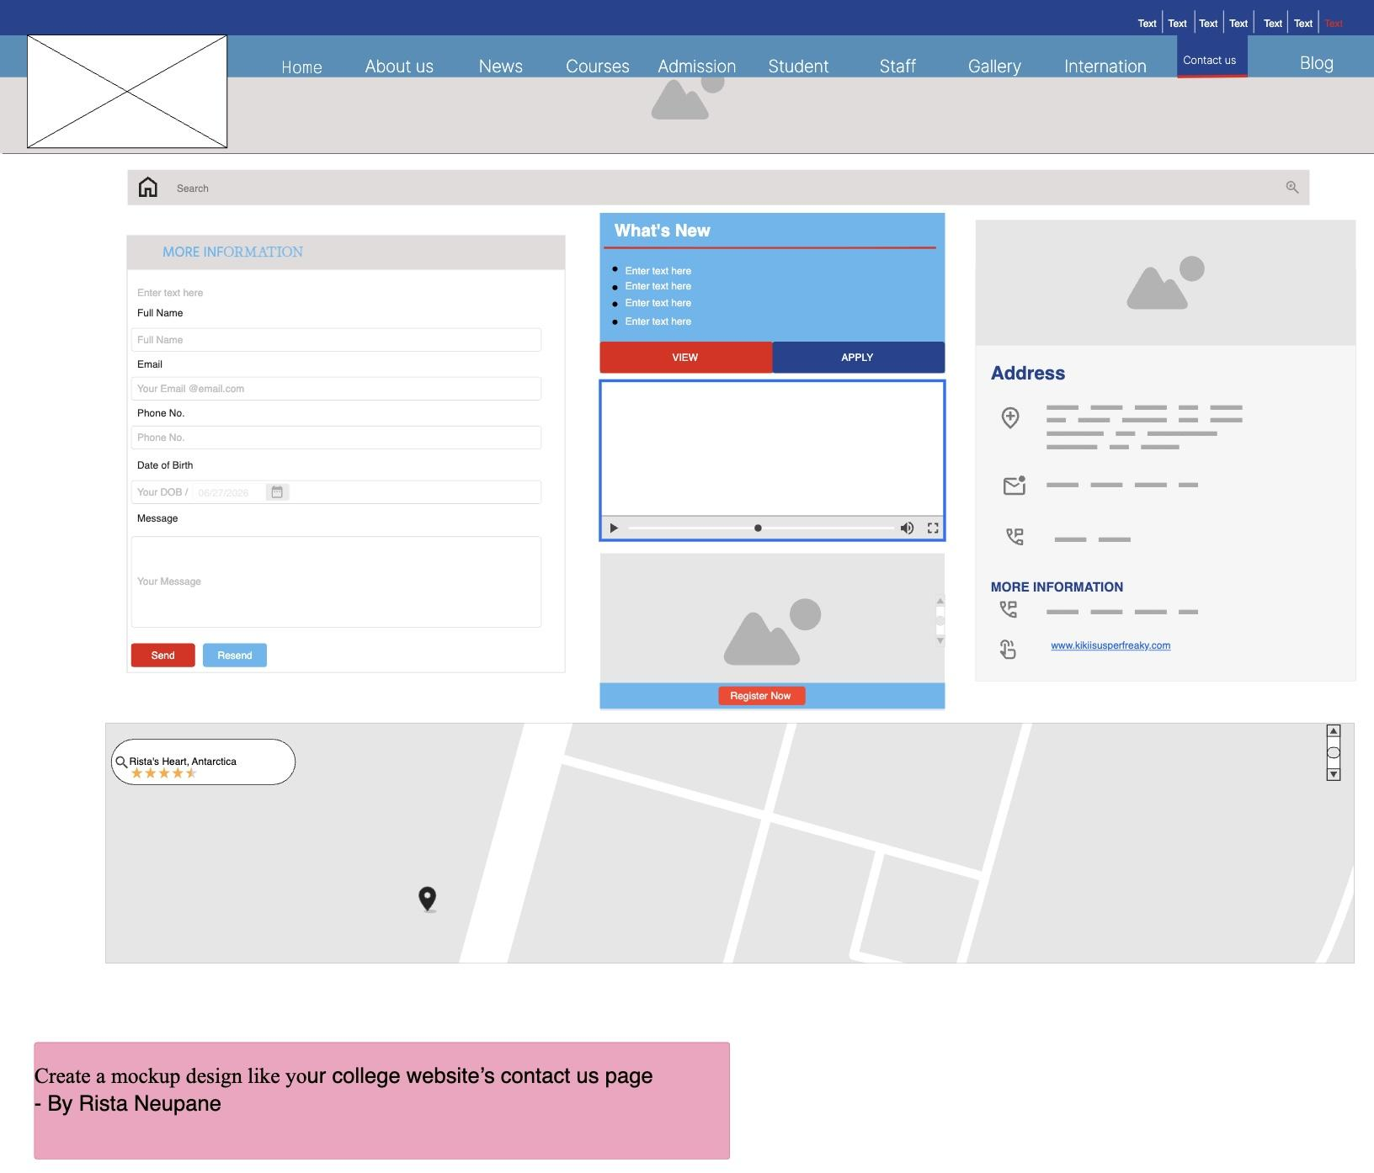
Final Prototype
https://app.moqups.com/68O9K8HUkZ4dYK0nPBQ2c6IiFWdQBkXX/view/page/ad64222d5

